“Welcome to Suwon Hwaseong!”:
Creating a Multimodal Introduction Video for a Historic Site in Korea

<<Scenario>>
Next year, South Korea will be hosting the 2018 Winter Olympics in PyeongChang, and it is expected that many tourists from all around the world will visit South Korea. Considering this, you and your partner will create an overview video introducing Suwon Hwaseong to foreign visitors.

<<Field Trip>>
We are going to visit Suwon Hwaseong this Saturday. To make your own introduction video, you will need to collect resources. We will take a tour with a guide, and you will be given about one and a half hours to collect information, video-record (film), take pictures, interview foreigners/Koreans visiting Suwon Hwaseong, etc. A video camera will be provided to each group. | 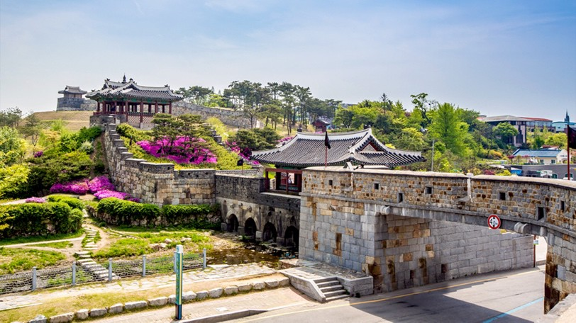

Photo taken from http://seoulkorea-tour.com/tour/suwon-hwaseong-fortress-morning-tour/

<<Things to Consider for Your Project>>
- Length of Video: At least 5 minutes
- Target Audience: English-speaking tourists visiting South Korea for the first time
- Purpose: Introduce Suwon Hwaseong and persuade foreign visitors to visit (i.e., After watching your video, you hope that they will decide to visit Suwon Hwaseong).

❗️ | To make an attractive and informative overview video, you must use available resources effectively—written text, audio, pictures, video recordings from the site, etc. Also, try to incorporate as many words as possible from the leaflet.

<<Creating Your Video>>

Step ① In-class planning
Plan your video project with your partner. Discuss the project in as much detail as possible. Read the leaflet and search for information on the Internet.
️ | These are things that you need to discuss:  - Content (i.e., What information to include)  - Format  - Plot/Organization  - What you should do while visiting Suwon Hwaseong this Saturday to collect resources

Content
(i.e., What information to include)
Format
Plot/Organization
What you should do while visiting Suwon Hwaseong this Saturday to collect resources

Step ② Field Trip: Collecting information about Suwon Hwaseong on site

During the field trip, you will first participate in a Korean-language tour with a guide. Afterwards, you will have time to collect resources that you want to include in your introduction video. The resources can be pictures, video-recordings, interviews with visitors, etc. Try to explore the site and see what activities or experiences you would like to introduce in your video to foreigners. Feel free to use the English-language audio guide for English commentary. Also, refer to your planning sheet that you worked on in our previous class with your group members.
Step ③ Creating Your Video (User Created Contents (UCC))

<<Things to Consider for Your Project>>

- Length of Your Video: Minimum 5 minutes (Maximum 9 minutes)
- Target Audience: English-speaking tourists visiting South Korea for the first time
- Purpose: Introduce Suwon Hwaseong and persuade foreign visitors to visit (i.e., After watching your video, you hope that they will decide to visit Suwon Hwaseong).

❗️ | To make an attractive and informative overview video, you must use available resources effectively—written text, audio, pictures, video recordings from the site, and interviews, etc. Also, try to incorporate as many words as possible from the leaflet.

<<A Tool for Creating/Editing Your Video: GomMix (곰믹스)>>
You will need to familiarize yourself with this tool before starting to edit your video.
- Visit the following blog (https://blog.naver.com/nanumup/221039937835) to see how to use this software or type “곰믹스 사용법” on Naver.
- Watch a tutorial for GomMix.

<<Possible Evaluation Criteria>>

- Content
- How well does your video present information about Suwon Hwaseong using relevant and sufficient facts, details, and/or explanations?
- How effectively does your video deliver information using speaking, writing, recordings, pictures, etc.?
- Language Use
- Do you show a well-developed command of English (language quality)?
- How much do you incorporate vocabulary/expressions from the leaflet into your own video?
- Creativity
- Does your video demonstrate original and interesting use of ideas, language, plot, and imagery?
- Collaboration
- How well did you and your partner collaborate on this project?

