**What is in your backpack?**

In my backpack I have…

|  |  |
| --- | --- |
| Spiral Notebook Clip Art Black and White | Spiral notebook, Notebook,  Coloring pages  ______________________ | The scissors in Doodle style.Scissors for seamstresses and hairdressers. Black and white image.Monochrome.Tools made of metal.Vector illustration  5393716 Vector Art at Vecteezy______________________ |
| Pencil Black And White Clipart Images | Free Download | PNG Transparent  Background - Pngtree  ________________________ | Free Binder Clipart Black And White, Download Free Binder Clipart Black And  White png images, Free ClipArts on Clipart Library  _________________________ |
| Premium Vector | Permanent marker for graffiti highlighter doodle linear  cartoon coloring  ________________________ | Free Cartoon Book Black And White, Download Free Cartoon Book Black And  White png images, Free ClipArts on Clipart Library  ________________________ |

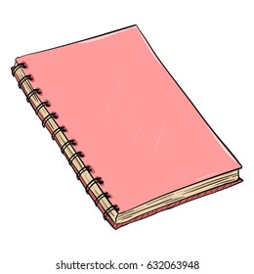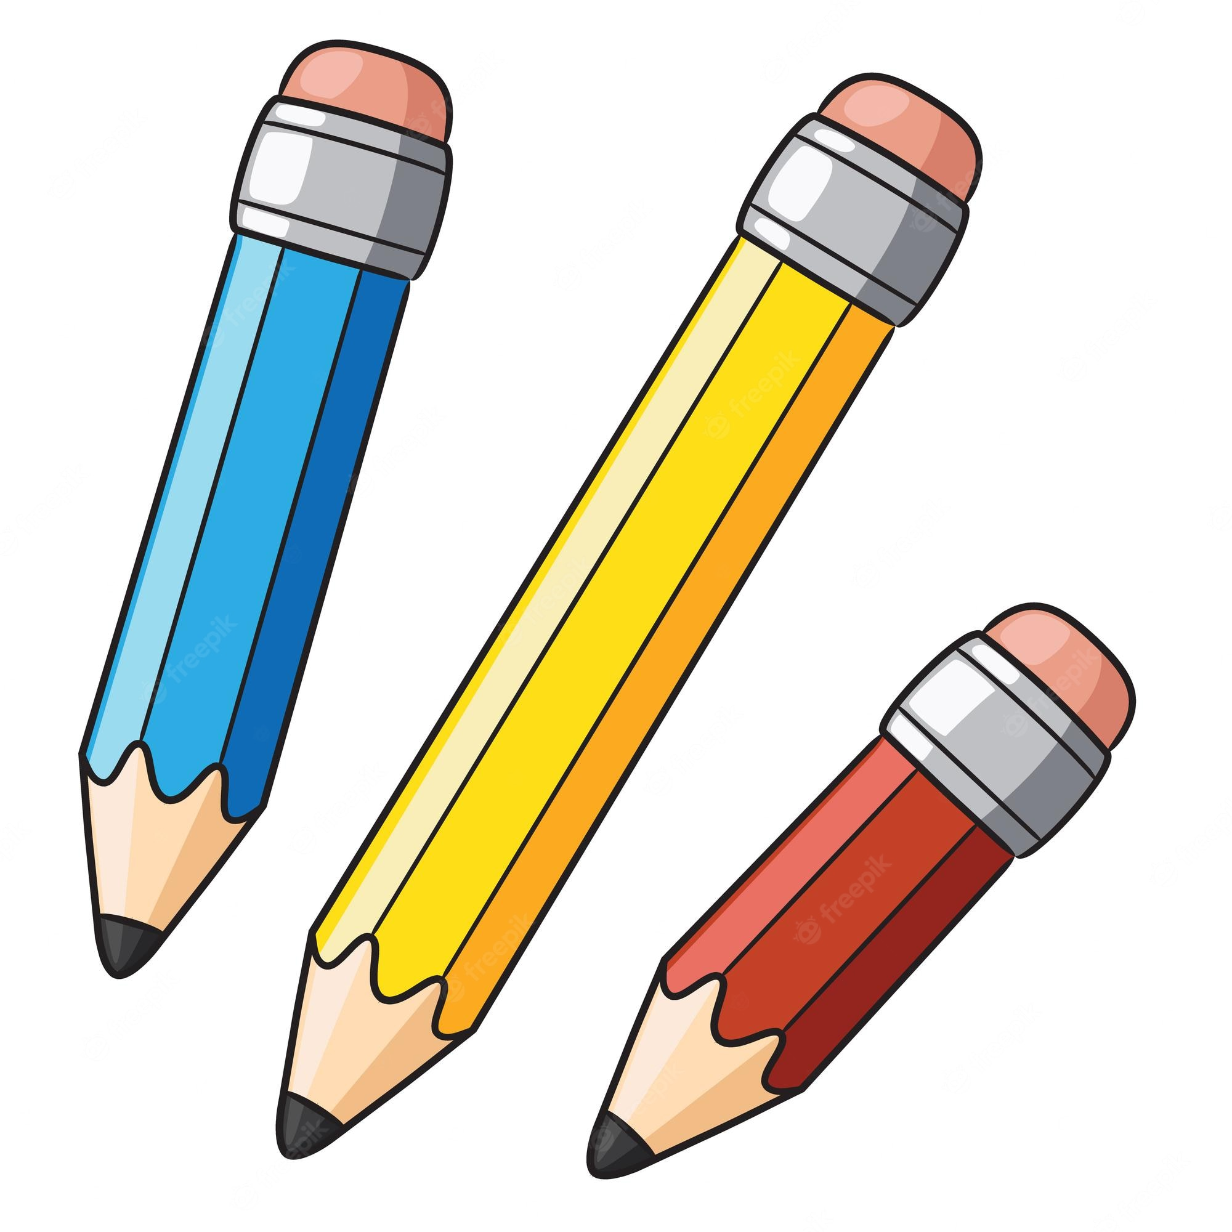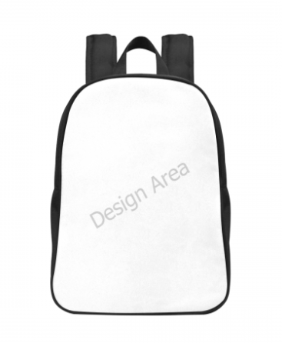My Back-To-School Backpack

My Back-To-School Backpack